**The Catapult:**

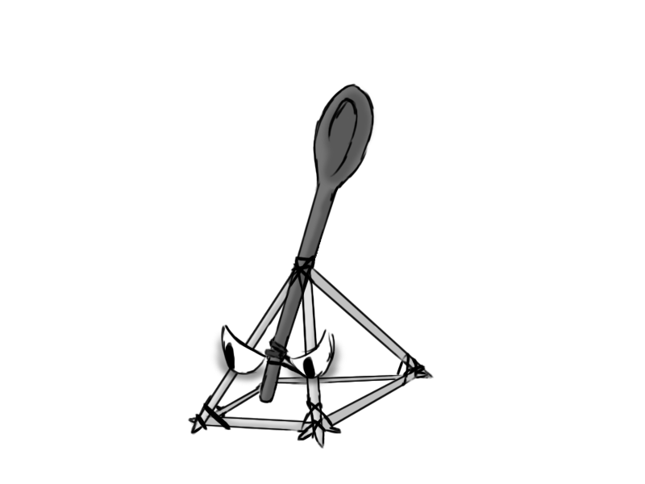

Figure - Enemy: Catapult

**Brief Synopsis**

The Catapult is a static enemy that will fire rocks from a distance. Each shot will display a crosshair on the floor 2 seconds before the fired rock lands. These enemies will essentially act as mortar fire, giving the player motivation to continuously move around the area. As they are static and slow firing, they are lower threat than enemies they could be partnered with. That said, the rocks that they fire can become a serious threat if not taken care of.

**Variants.**

There will be no variants for the catapult, instead there is the possibility of varying the ammo type that is fired from them.

**AI**

The AI will simply try to find the player's position and fire a rock in that vicinity. These attacks can also damage the enemies so the player could bait the catapult and the enemies at the same time, dealing damage to a group of enemies without damaging themselves.

**Animations**

The catapult has three states- idle, attacking and death.

**Idle:**

* Sits in one place, with ammo loaded.

**Attacking:**

* Rubber band gets pulled downwards, with a rock loaded, and then gets fired up into the air.

**Death:**

* It will fall apart.

**Average Size**

